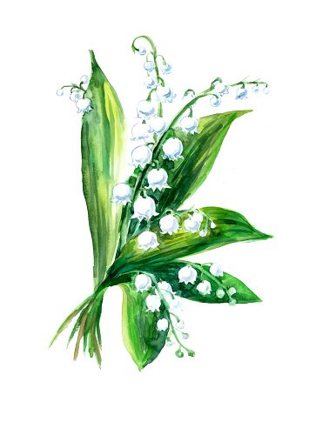
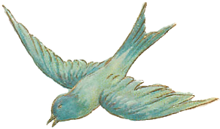
A Celebration of the Life of Carol Hird

We will gather virtually, via Zoom, to honour and celebrate a life well-lived.
Links and instructions to follow the week prior to the Ceremony.
Celebrant: Paula Skalnek
Host: Brian Burtch
RSVP: burtch@sfu.ca
July 17, 2021
10:30 PDT
On Saturday, cozy up to your screens with your favorite snacks and beverages to join family, friends and colleagues from across the globe to honour Our Carol.
Please have a candle and something to light it with in order to participate in a simple ritual during the Ceremony.
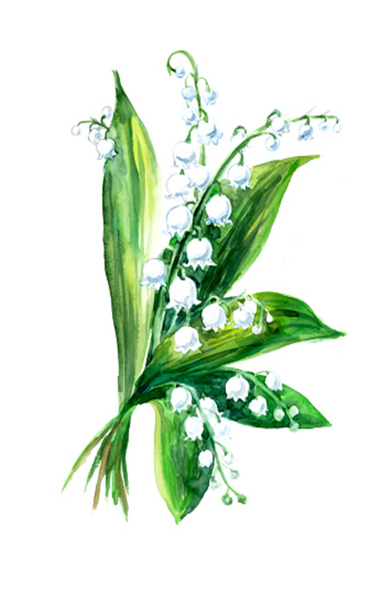
Celebrant: Paula Skalnek
Host: Brian Burtch

Your Zoom link:

